Relational Database Design and Implementation

Trayvonious Pendleton

WGU

Course Number: D597

STUDENT ID: 011205284

PART A1

EcoMart, an emerging online marketplace that fosters sustainability and environmental consciousness, requires a robust and efficient database solution to address challenges associated with managing its diverse and dynamic product data as a platform catering to eco-conscious consumers. EcoMart offers various products across categories such as groceries, apparel, home goods, and personal care items, each with unique attributes like sustainability certifications, pricing, availability, and user reviews. The current system struggles to accommodate the increasing volume and complexity of data, leading to inefficiencies in operations, delays in data retrieval, and limitations in scalability. To meet its goals of providing a seamless customer experience and supporting its mission to promote eco-friendly practices, EcoMart has decided to adopt a relational database solution. This database will ensure scalability, optimize performance, and maintain data integrity while implementing stringent security measures to protect sensitive customer information. Furthermore, a comprehensive monitoring and maintenance workflow will proactively address performance bottlenecks, security vulnerabilities, and data inconsistencies, ensuring the platform’s long-term stability and reliability. By resolving these issues, EcoMart can continue to connect environmentally conscious consumers with sustainable brands and products, aligning with its vision of fostering a greener future.

# PART A2

## The business problem involves creating a scalable, efficient, and secure database to manage the dynamic and diverse range of EcoMart’s eco-friendly products and associated data. To address this, the following logical data model is proposed:

**Entities and Their Relationships:**

**Regions**

**Attributes:** RegionID (Primary Key), RegionName.

**Purpose**: Represents geographic regions for categorizing countries and analyzing regional sales data.

**Countries**

**Attributes:** CountryID (Primary Key), CountryName, RegionID (Foreign Key).

**Purpose:** Links countries to their respective regions for localized analysis and tracking.

**Product Categories**

**Attributes:** CategoryID (Primary Key), CategoryName.

**Purpose:** Groups products into logical categories (e.g., groceries, apparel).

**Products**

**Attributes**: ProductID (Primary Key), ProductName, CategoryID (Foreign Key),SustainabilityCertifications, Description.

**Purpose:** Stores details about individual products and links them to categories.

**Sales Channels**

**Attributes:** ChannelID (Primary Key), ChannelName (e.g., Online, Offline).

**Purpose**: Tracks sales channels for order distribution analysis.

**Order Priorities**

**Attributes:** PriorityID (Primary Key), PriorityName (e.g., High, Medium, Low, Critical).

**Purpose**: Represents the priority levels of orders for fulfillment planning.

**Customers**

**Attributes**: CustomerID (Primary Key), Name, Email, Address, PhoneNumber.

**Purpose:** Stores customer details, enabling tracking of customer orders and improving customer engagement.

**Orders**

**Attributes**: OrderID (Primary Key), OrderDate, ShipDate, CustomerID (Foreign Key), CountryID (Foreign Key), ChannelID (Foreign Key), PriorityID (Foreign Key), TotalRevenue, TotalCost, TotalProfit.

**Purpose**: Captures transactional data for orders, including financial metrics and customer associations.

**Order Details**

**Attributes:** OrderDetailID (Primary Key), OrderID (Foreign Key), ProductID (Foreign Key), UnitsSold, UnitPrice, UnitCost.

**Purpose:** Tracks individual items within each order, including quantities and pricing details.

**Relationships Between Entities**

* **Regions and Countries**: One-to-Many (A region can have many countries).
* **Countries and Orders**: One-to-Many (An order is linked to a specific country).
* **Product Categories and Products**: One-to-Many (A category can contain multiple products).
* **Products and Order Details**: One-to-Many (An order detail references one product).
* **Orders and Customers**: Many-to-One (A customer can place multiple orders).
* **Orders and Order Details**: One-to-Many (Each order can include multiple order details (items), and each order detail is linked to one order)
* **Sales Channels and Orders**: One-to-Many (Each sales channel (e.g., Online, Offline) can be associated with multiple orders, but each order is linked to only one sales channel.)
* **Order Priorities and Orders**: One-to-Many (Each order priority (e.g., High, Medium, Low, Critical) can apply to multiple orders, but each order has one priority level.)

## PART A3

### EcoMart requires a scalable, efficient, and secure system to manage its diverse eco-friendly products, ensure smooth order processing, and derive actionable insights from customer data. A relational database solution is ideal for addressing these challenges as it provides a structured way to store, organize, and retrieve interconnected data. By normalizing the data, the database minimizes redundancy and maintains consistency, allowing EcoMart to manage a growing volume of products, orders, and customers effectively.

### Using relational links between entities (e.g., orders, products, and customers) ensures data integrity while enabling complex queries to generate insights such as sales trends, regional performance, and customer preferences. For example, the database can efficiently analyze product demand by region or identify the most profitable sales channels. Furthermore, relational databases support robust security features such as encryption and access controls, protecting sensitive customer and transaction data. This approach aligns with EcoMart's need for a flexible, scalable, and secure solution, ensuring the platform remains reliable as data volumes and user traffic grow.

### PART A4

The proposed database solution will enable EcoMart to streamline operations, enhance decision-making, and improve customer satisfaction by providing efficient access to critical data. Each table in the database stores specific data entities, such as products, orders, and customers, while foreign keys link these entities to create meaningful relationships.

EcoMart’s product data, including categories, descriptions, pricing, availability, and sustainability certifications, will help customers quickly find and purchase products that align with their values. The Orders table will centralize all transactional data, linking customers, products, sales channels, and order priorities. This structure allows real-time tracking of order fulfillment and financial metrics like total revenue, cost, and profit.

The database also supports data-driven decision-making by enabling the generation of reports and dashboards. For instance, sales trends by region or product category can be analyzed using data from the Regions, Countries, and Products tables. The Order Priorities table also helps EcoMart optimize fulfillment strategies by categorizing and managing high-priority orders.

The database provides a flexible and scalable framework to accommodate EcoMart’s growing operations while ensuring data security and enabling advanced analytics to improve customer experience and business performance continuously.

PART B

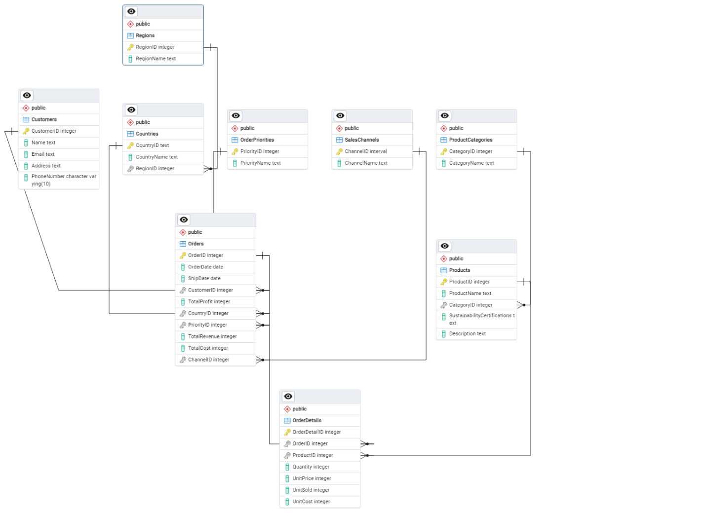

PART C

The proposed database solution for EcoMart includes a well-structured set of tables designed to store and manage the organization’s business data efficiently. The Regions table captures geographic regions to classify and analyze sales data, while the Countries table links countries to their respective areas, enabling localized insights. The Product Categories and Products tables organize items into logical groups with detailed attributes such as sustainability certifications and descriptions. Sales data is streamlined through the Sales Channels table, which tracks channels like online and offline sales, and the Order Priorities table, which manages the priority levels of orders for optimized fulfillment.

The Customers table securely stores customer details, including names, addresses, and contact information, supporting personalized customer engagement and efficient order management. The Orders table centralizes transactional data, including order dates, shipment details, and financial metrics like total revenue, cost, and profit, while linking to customers, countries, sales channels, and priorities. The Order Details table records the specifics of each order, such as products, units sold, unit prices, and costs, providing granular insights into individual transactions.

This database design ensures fast and efficient data storage, retrieval, and querying by utilizing primary and foreign keys to establish relationships between entities. Sensitive customer data is secured through encryption, and historical records can be archived to maintain performance while preserving essential data for compliance and analysis. The structured and scalable design aligns with EcoMart’s operational and analytical needs, ensuring data integrity and supporting business growth.

**PART D**

The proposed database design addresses scalability concerns by implementing strategies that ensure the system can handle increasing data volumes, user traffic, and operational complexity as EcoMart grows. Normalizing the data into separate tables minimizes redundancy, reduces storage requirements, and improves query efficiency. The database can easily accommodate new product categories, countries, or sales channels without requiring significant redesign by organizing data into logical entities, such as products, customers, and orders.

Even as the dataset expands, indexing is used on primary and foreign keys to optimize query performance. For example, indexing on attributes like OrderDate, CountryID, and ProductID enables quick data retrieval for reports and analytics. Partitioning can also be implemented to distribute large datasets, such as orders, across multiple storage locations based on attributes like region or date, further enhancing performance.

To support high user traffic, the database can leverage horizontal scaling by replicating the database across multiple servers. This setup ensures load balancing and high availability, reducing the risk of bottlenecks. Regular performance monitoring and tuning, such as analyzing slow queries and optimizing indexes, will be implemented to address evolving demands. These strategies ensure the database remains reliable, fast, and flexible, even as EcoMart’s platform scales to accommodate more users and data.

**PART E**

The database design incorporates robust privacy and security measures to protect sensitive customer and business data. Customer information, such as email addresses and phone numbers, will be encrypted at rest and in transit to prevent unauthorized access. Access to the database will be restricted based on roles, ensuring that only authorized personnel can view or modify specific data. For example, customer service representatives may access customer profiles but not financial data.

Audit logging will be implemented to track all access and modifications to the database, providing a record for identifying and addressing potential security breaches. Regular backups will ensure data recovery in case of accidental loss or system failure. The system will also comply with data privacy regulations, such as GDPR or CCPA, by providing mechanisms for customers to request data deletion or review.

Database administrators and users must have strong password policies and multi-factor authentication to enhance security further. Regular vulnerability assessments and penetration testing will be conducted to identify and address security gaps. These measures collectively ensure that EcoMart’s database is secure, compliant with regulations, and capable of protecting customer trust and business integrity.

**Part F1**

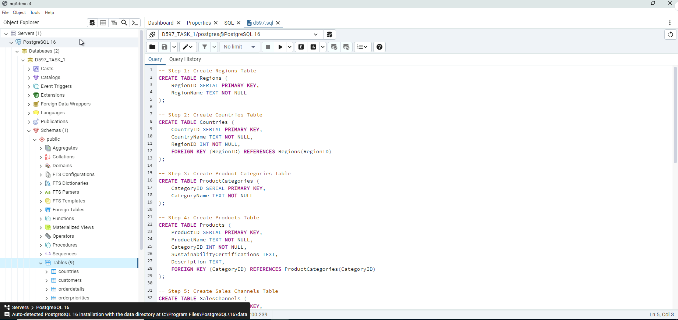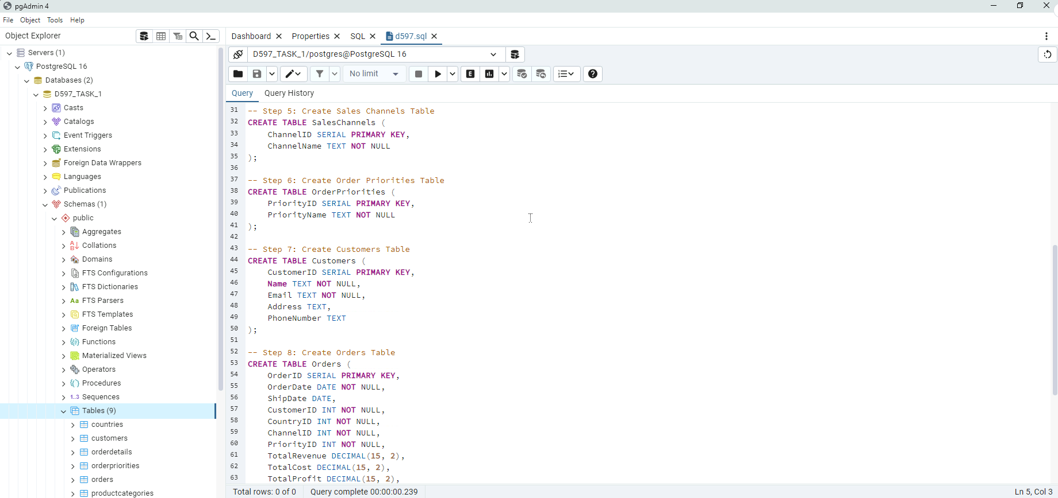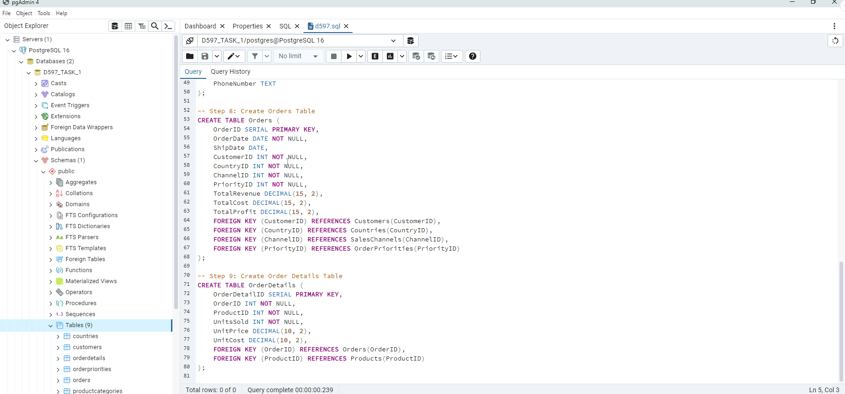**Part F2**

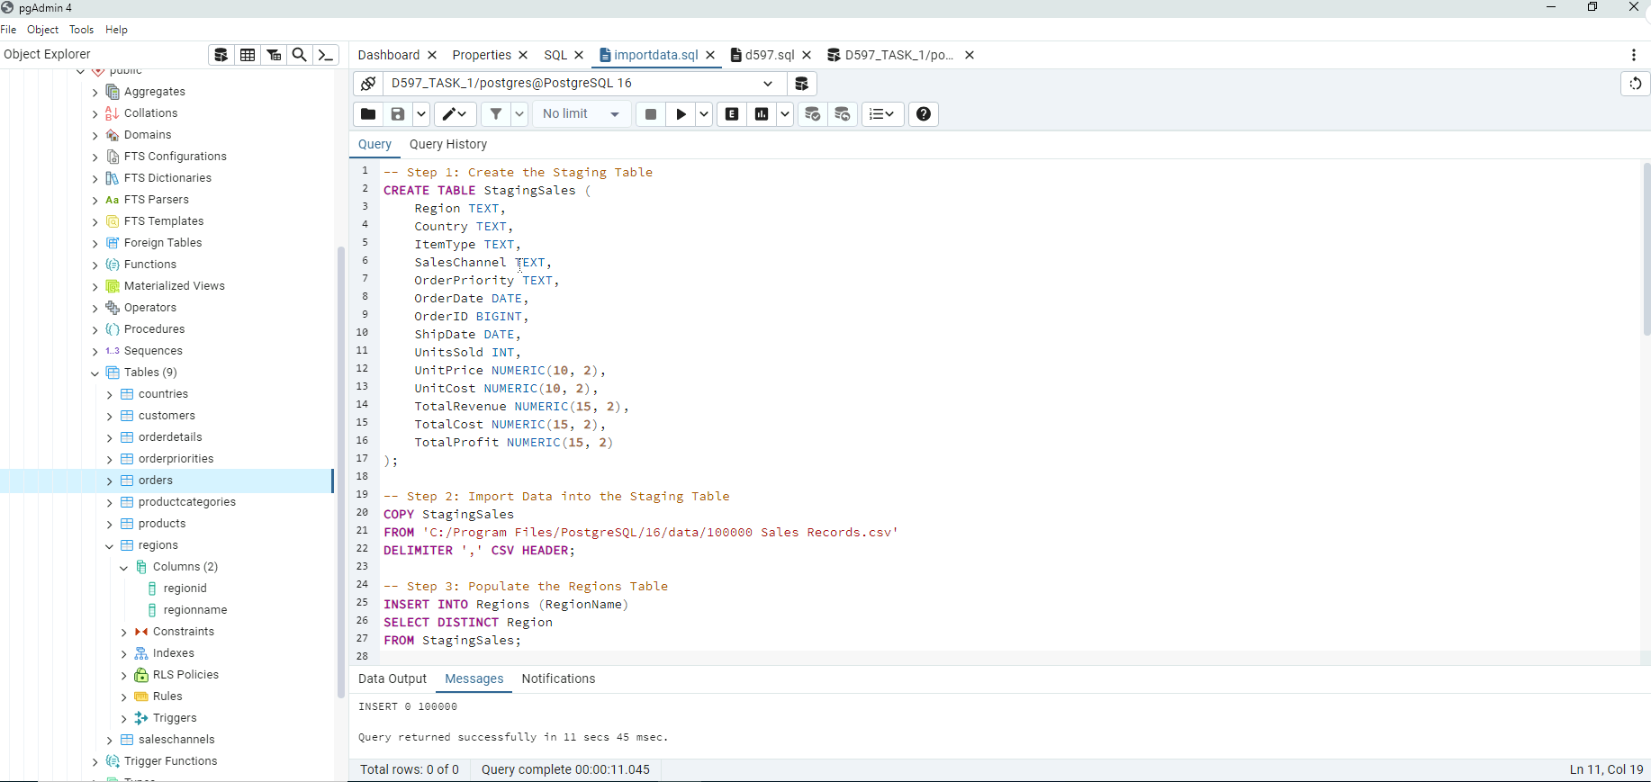

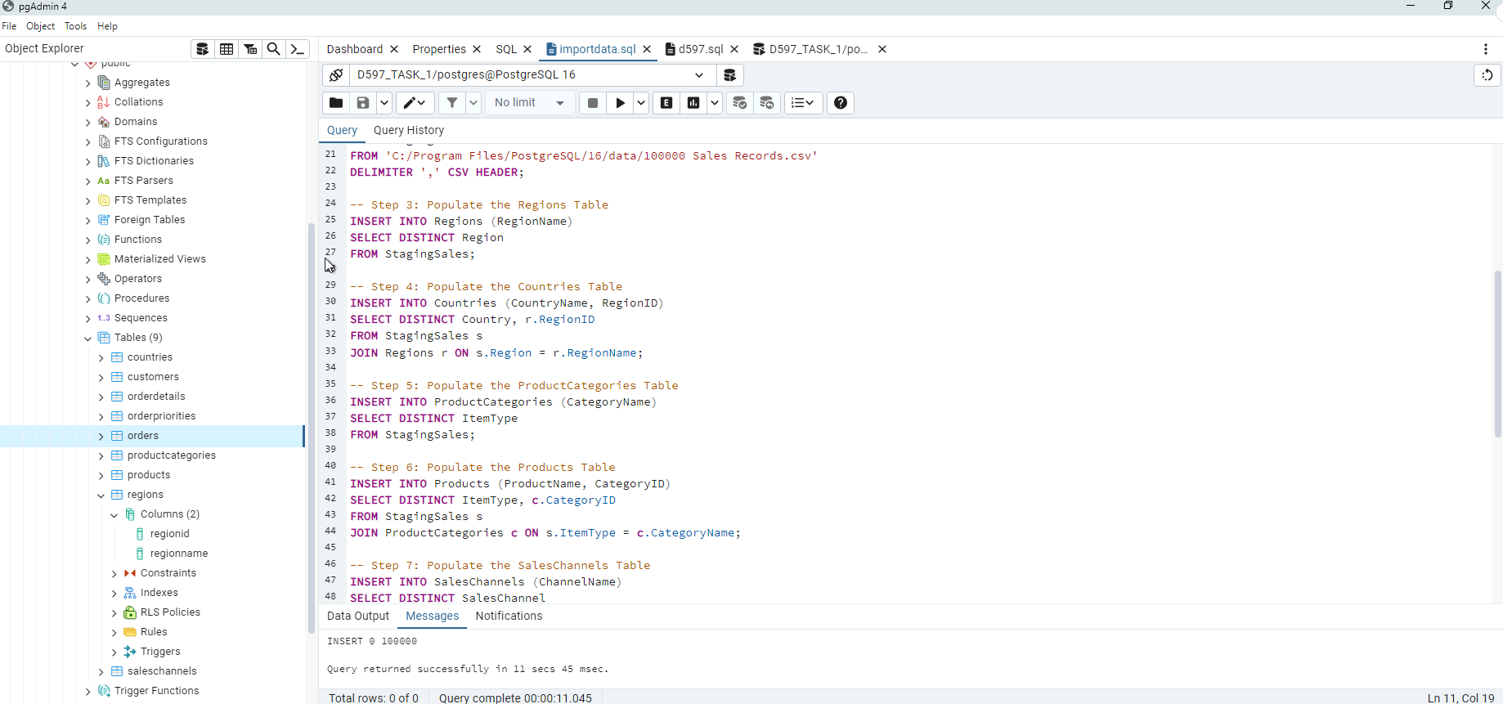

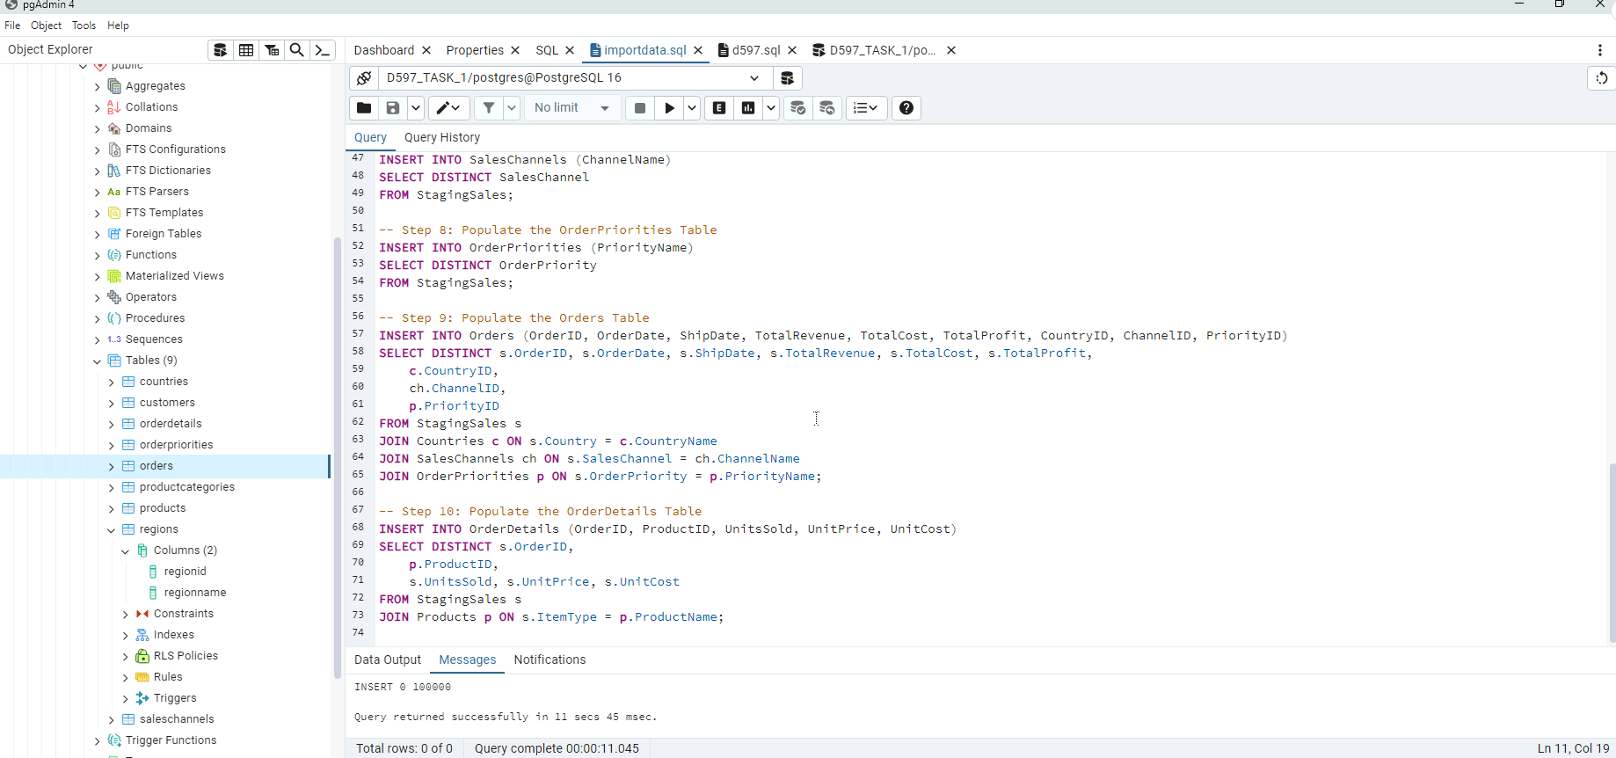

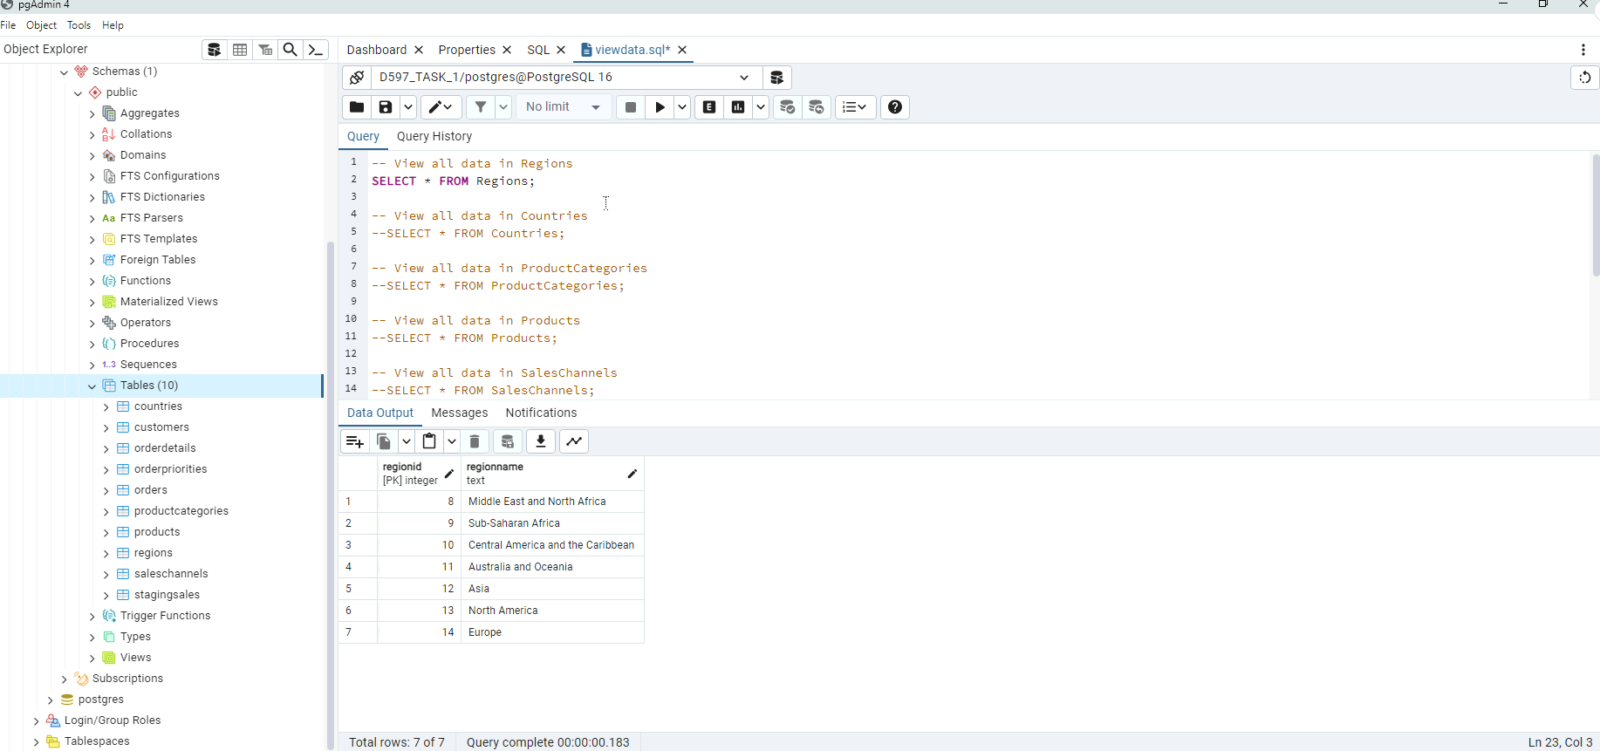

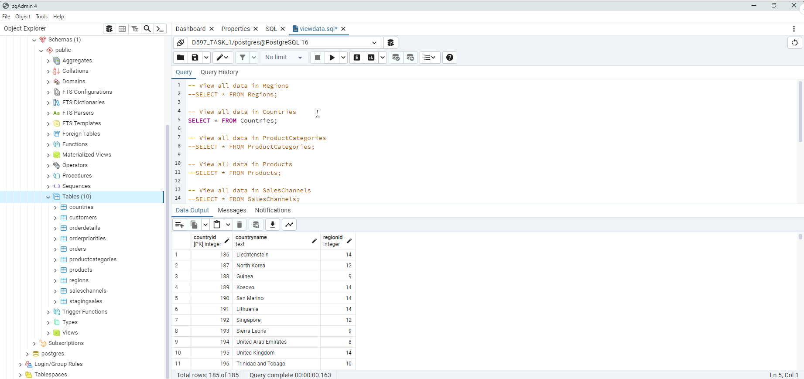

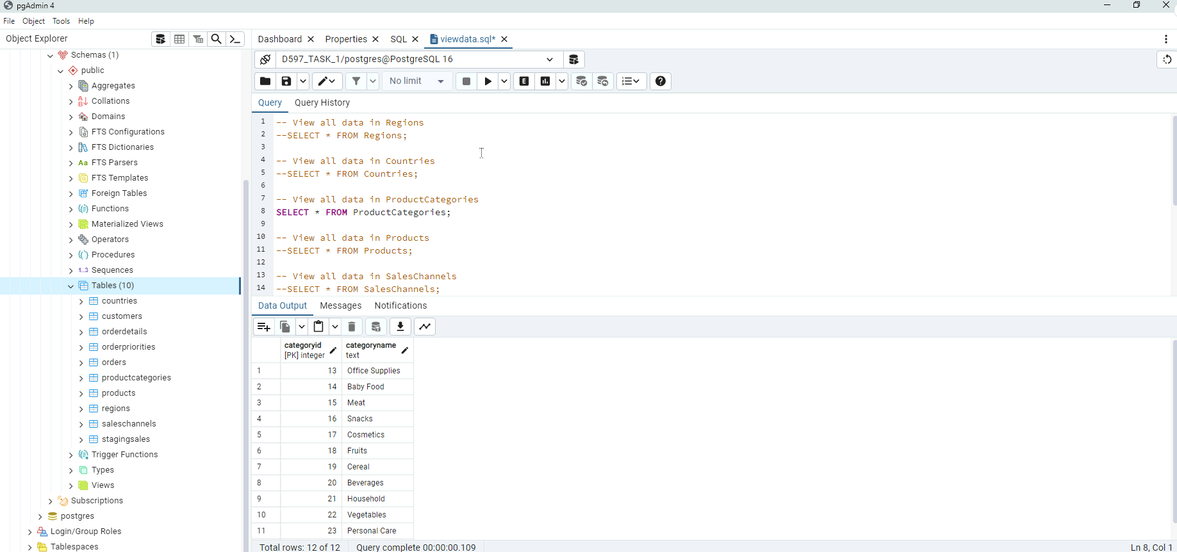

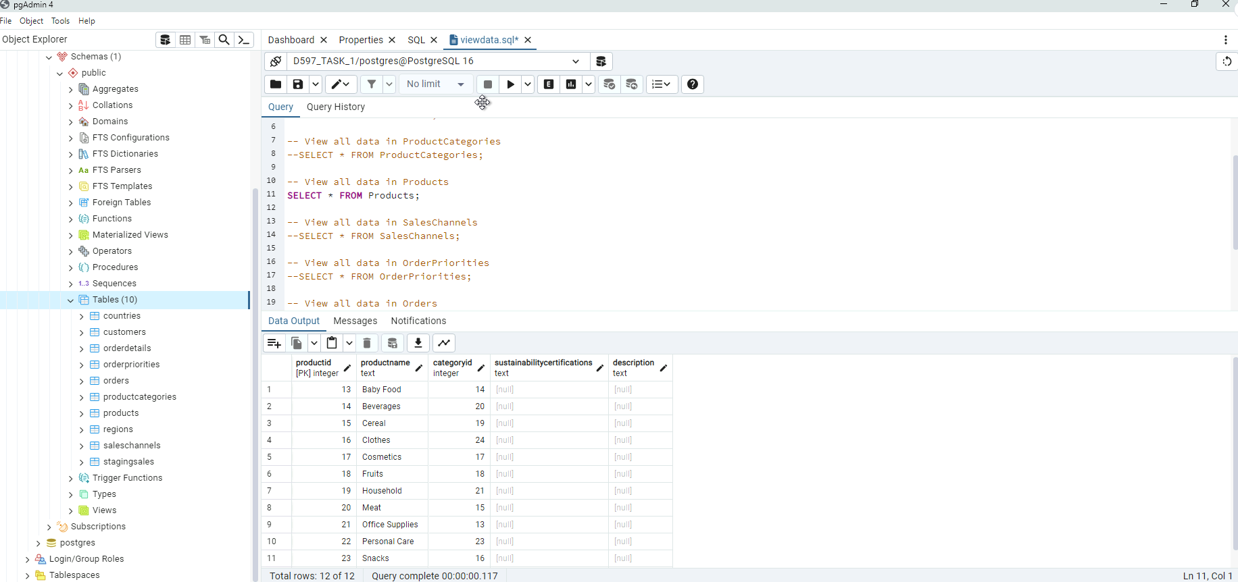

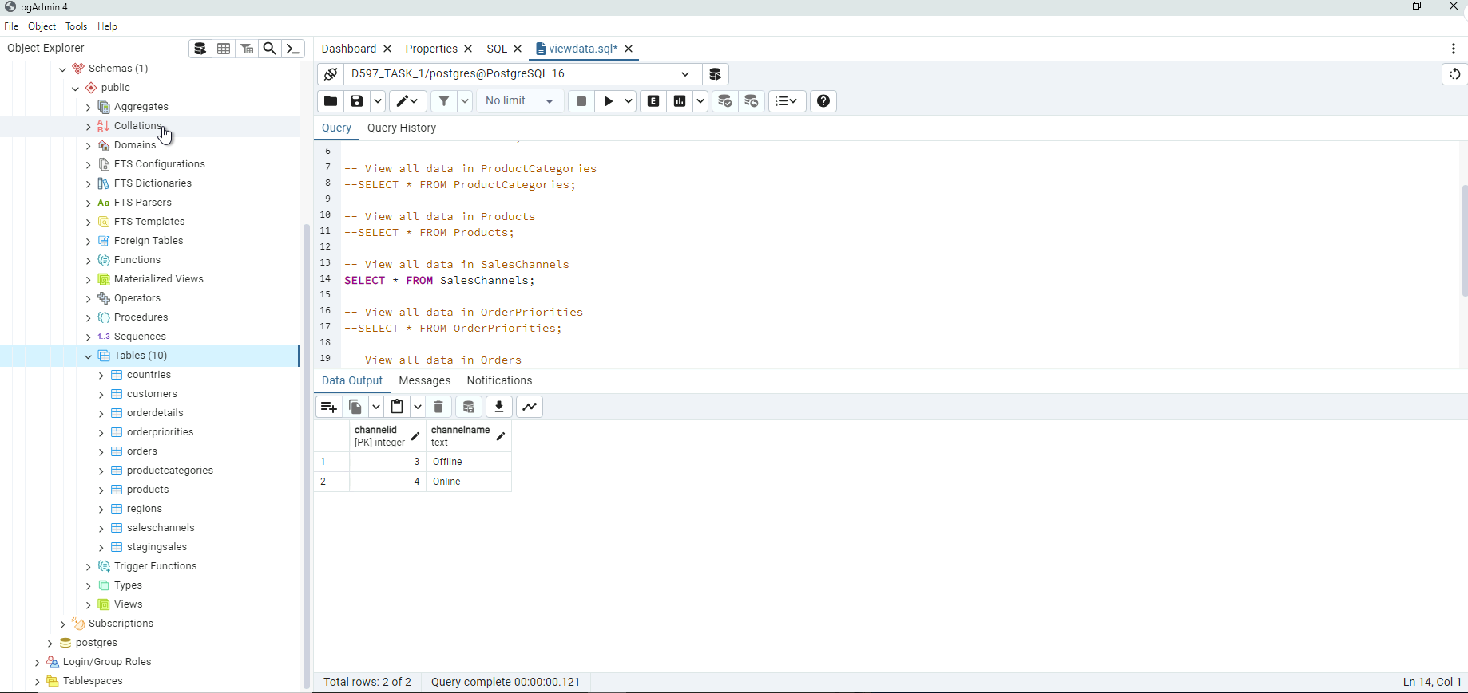

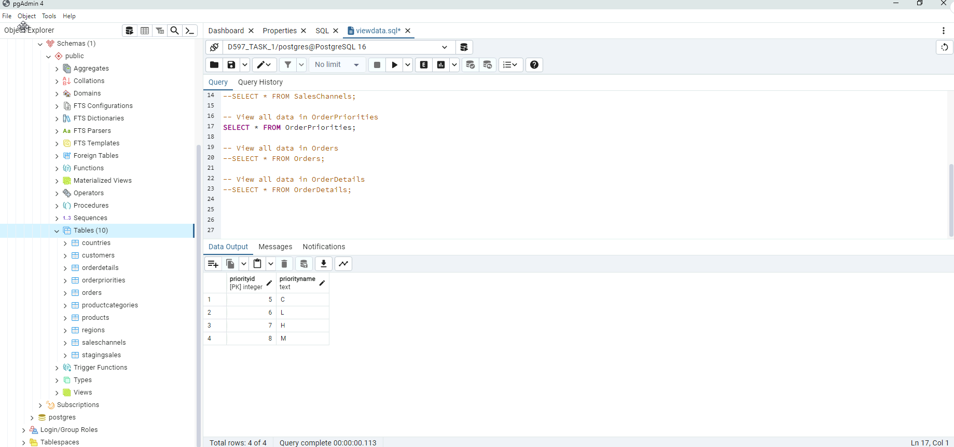

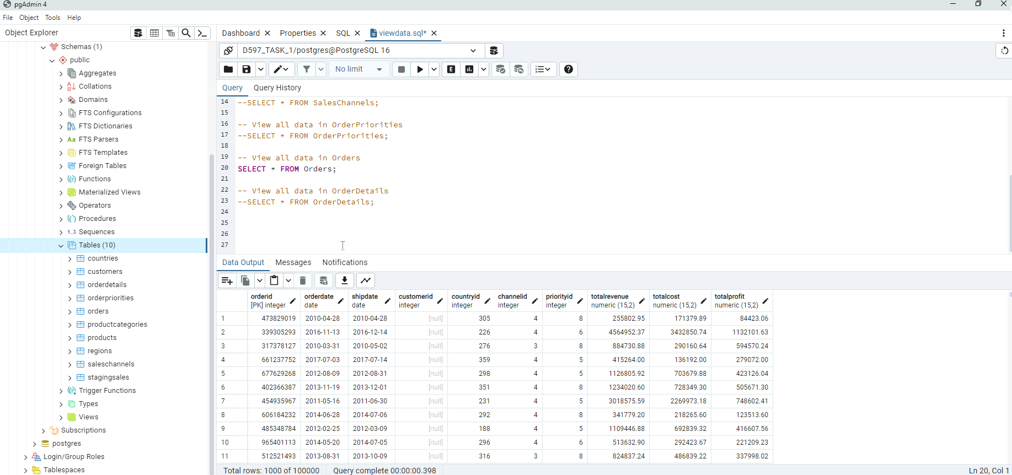

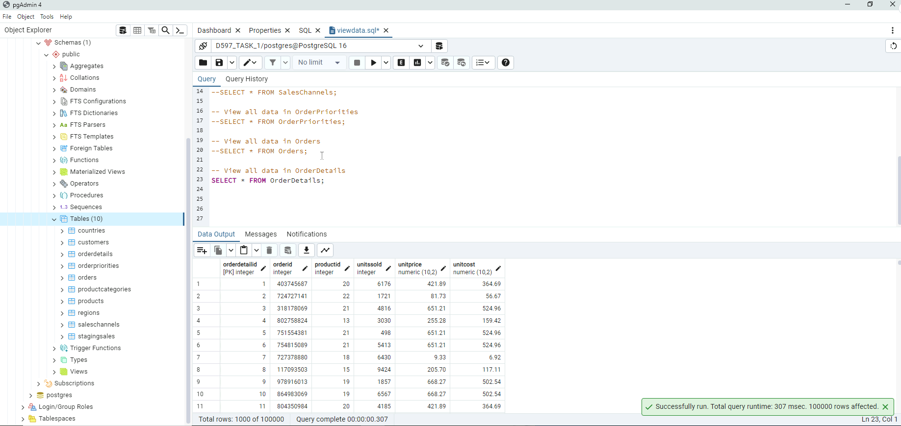

**Part F3**

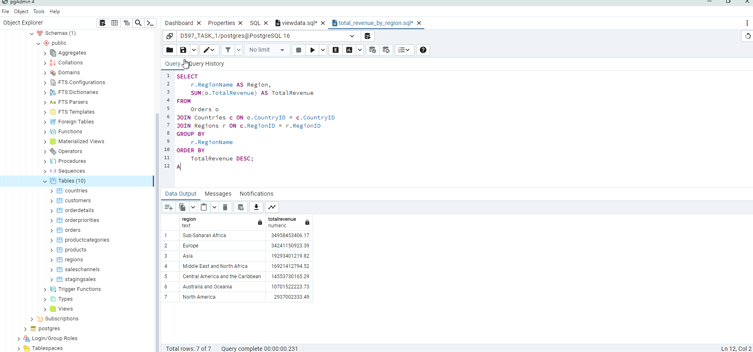

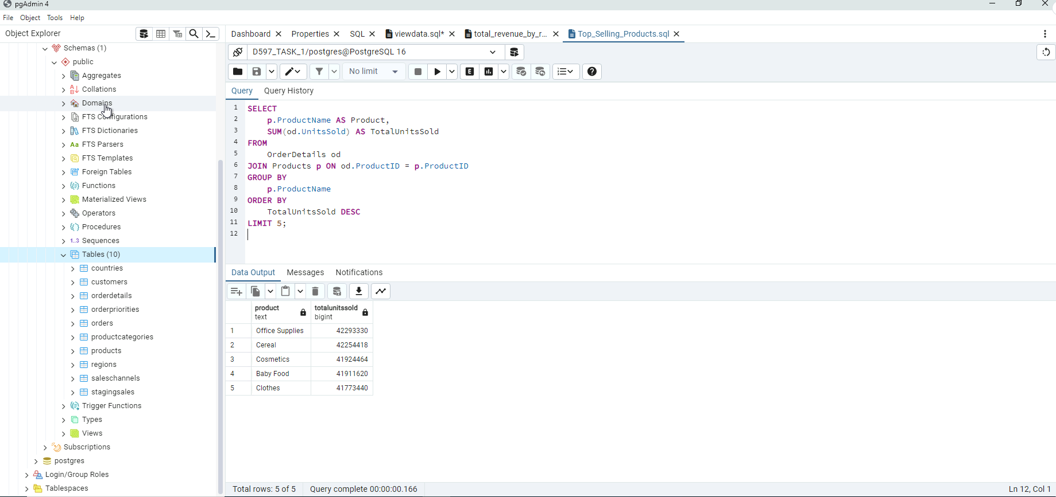

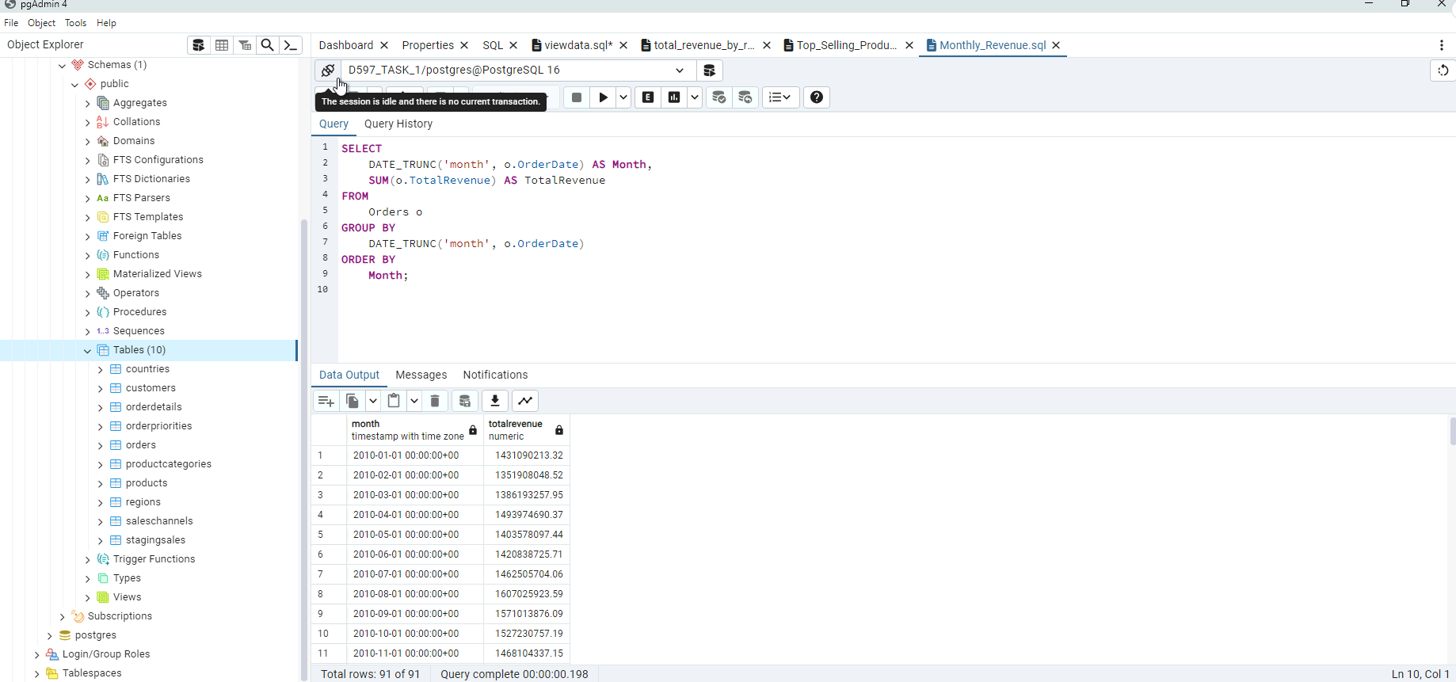

**Part F4**

